**Tutorial – 6**

1. Create file "first.txt" using File class. Implement following methods.

(i)createNewFile

(ii)getName

(iii)getAbsolutePath

(iv)canRead

(v)canWrite

(vi)canRead

(vii)length

(viii)canFile

(ix)canDirectory

(x)exists

**Code:**

import java.io.File;

public class Main {

    public static void main(String[] args) {

        File file = new File("first.txt");

*// createNewFile method*

        try {

            boolean created = file.createNewFile();

            if (created) {

                System.out.println("File created successfully.");

            } else {

                System.out.println("File already exists.");

            }

        } catch (Exception e) {

            System.out.println("An error occurred while creating the file.");

            e.printStackTrace();

        }

*// getName method*

        String fileName = file.getName();

        System.out.println("File name: " + fileName);

*// getAbsolutePath method*

        String absolutePath = file.getAbsolutePath();

        System.out.println("Absolute path: " + absolutePath);

*// canRead method*

        boolean readable = file.canRead();

        System.out.println("Readable: " + readable);

*// canWrite method*

        boolean writable = file.canWrite();

        System.out.println("Writable: " + writable);

*// isFile method*

        boolean isFile = file.isFile();

        System.out.println("Is file: " + isFile);

*// isDirectory method*

        boolean isDirectory = file.isDirectory();

        System.out.println("Is directory: " + isDirectory);

*// length method*

        long length = file.length();

        System.out.println("File length: " + length);

*// exists method*

        boolean exists = file.exists();

        System.out.println("File exists: " + exists);

    }

}

**Output Screenshot:**

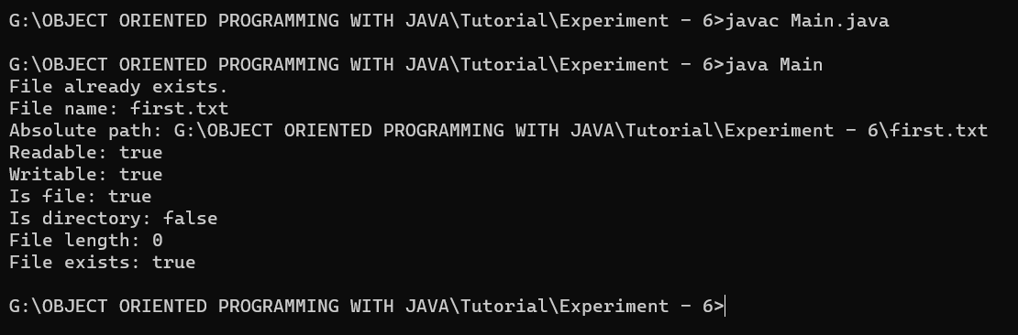

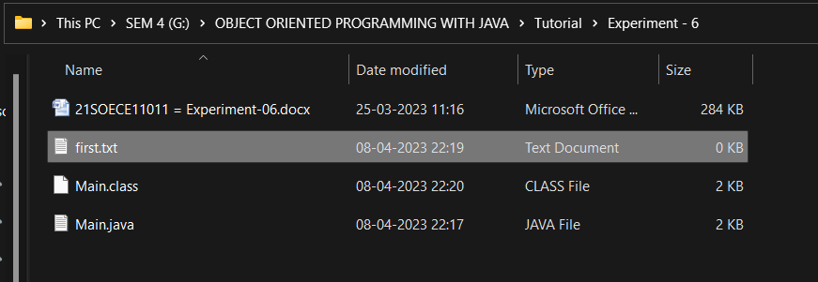

1. Create file "second.txt" using File class  and Change file name using renameTo.

**Code:**

import java.io.File;

public class Main2 {

    public static void main(String[] args) {

        File file = new File("second.txt");

*// createNewFile method*

        try {

            boolean created = file.createNewFile();

            if (created) {

                System.out.println("File created successfully.");

            } else {

                System.out.println("File already exists.");

            }

        } catch (Exception e) {

            System.out.println("An error occurred while creating the file.");

            e.printStackTrace();

        }

*// renameTo method*

        File newFile = new File("newSecond.txt");

        boolean renamed = file.renameTo(newFile);

        if (renamed) {

            System.out.println("File renamed successfully.");

        } else {

            System.out.println("Failed to rename file.");

        }

    }

}

**Output Screenshot:**

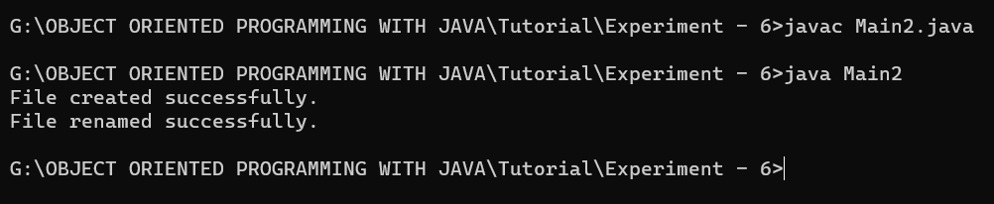

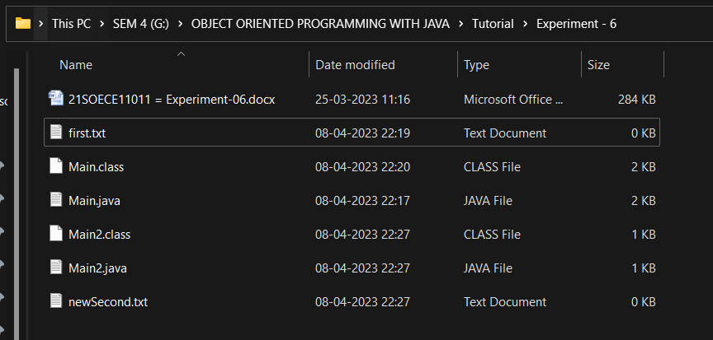

1. Modify question 2  and perform delete operation using delete().

**Code:**

import java.io.File;

public class Main3 {

    public static void main(String[] args) {

        File file = new File("second.txt");

*// createNewFile method*

        try {

            boolean created = file.createNewFile();

            if (created) {

                System.out.println("File created successfully.");

            } else {

                System.out.println("File already exists.");

            }

        } catch (Exception e) {

            System.out.println("An error occurred while creating the file.");

            e.printStackTrace();

        }

*// renameTo method*

        File newFile = new File("newSecond.txt");

        boolean renamed = file.renameTo(newFile);

        if (renamed) {

            System.out.println("File renamed successfully.");

        } else {

            System.out.println("Failed to rename file.");

        }

*// delete method*

        boolean deleted = newFile.delete();

        if (deleted) {

            System.out.println("File deleted successfully.");

        } else {

            System.out.println("Failed to delete file.");

        }

    }

}

**Output Screenshot:**

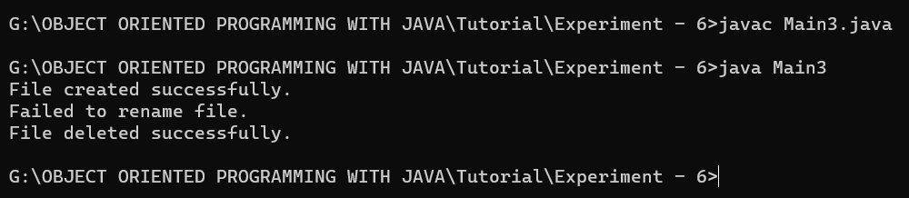

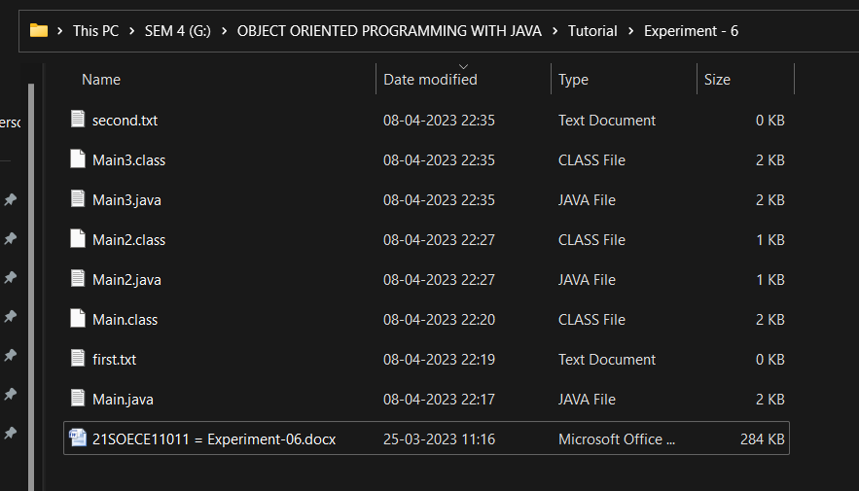

1. Find the error in given code, also complete the given code and correct it.

import java.io.File;

class File  
{  
public static void main(String args[])  
{  
try  
{  
File f=new File("D\File\");  
  
}  
catch()  
{  
System.out.println(i);  
}  
}  
}

Expected output:  
  
File Created:false  
File name is:File1.txt  
File path isD:\RKU\First.java  
File read operation:true  
File write operationtrue  
File length in bytes:0  
is File:true  
is directory:false  
is exists:true

**Code:**

import java.io.File;

import java.io.IOException;

public class Main4 {

    public static void main(String args[]) {

        try {

            File f = new File("D:\\File1.txt");

            boolean created = f.createNewFile();

            System.out.println("File Created: " + created);

            System.out.println("File name is: " + f.getName());

            System.out.println("File path is " + f.getAbsolutePath());

            System.out.println("File read operation: " + f.canRead());

            System.out.println("File write operation: " + f.canWrite());

            System.out.println("File length in bytes: " + f.length());

            System.out.println("Is file: " + f.isFile());

            System.out.println("Is directory: " + f.isDirectory());

            System.out.println("File exists: " + f.exists());

        } catch (IOException e) {

            System.out.println(e);

        }

    }

}

**Output Screenshot:**

